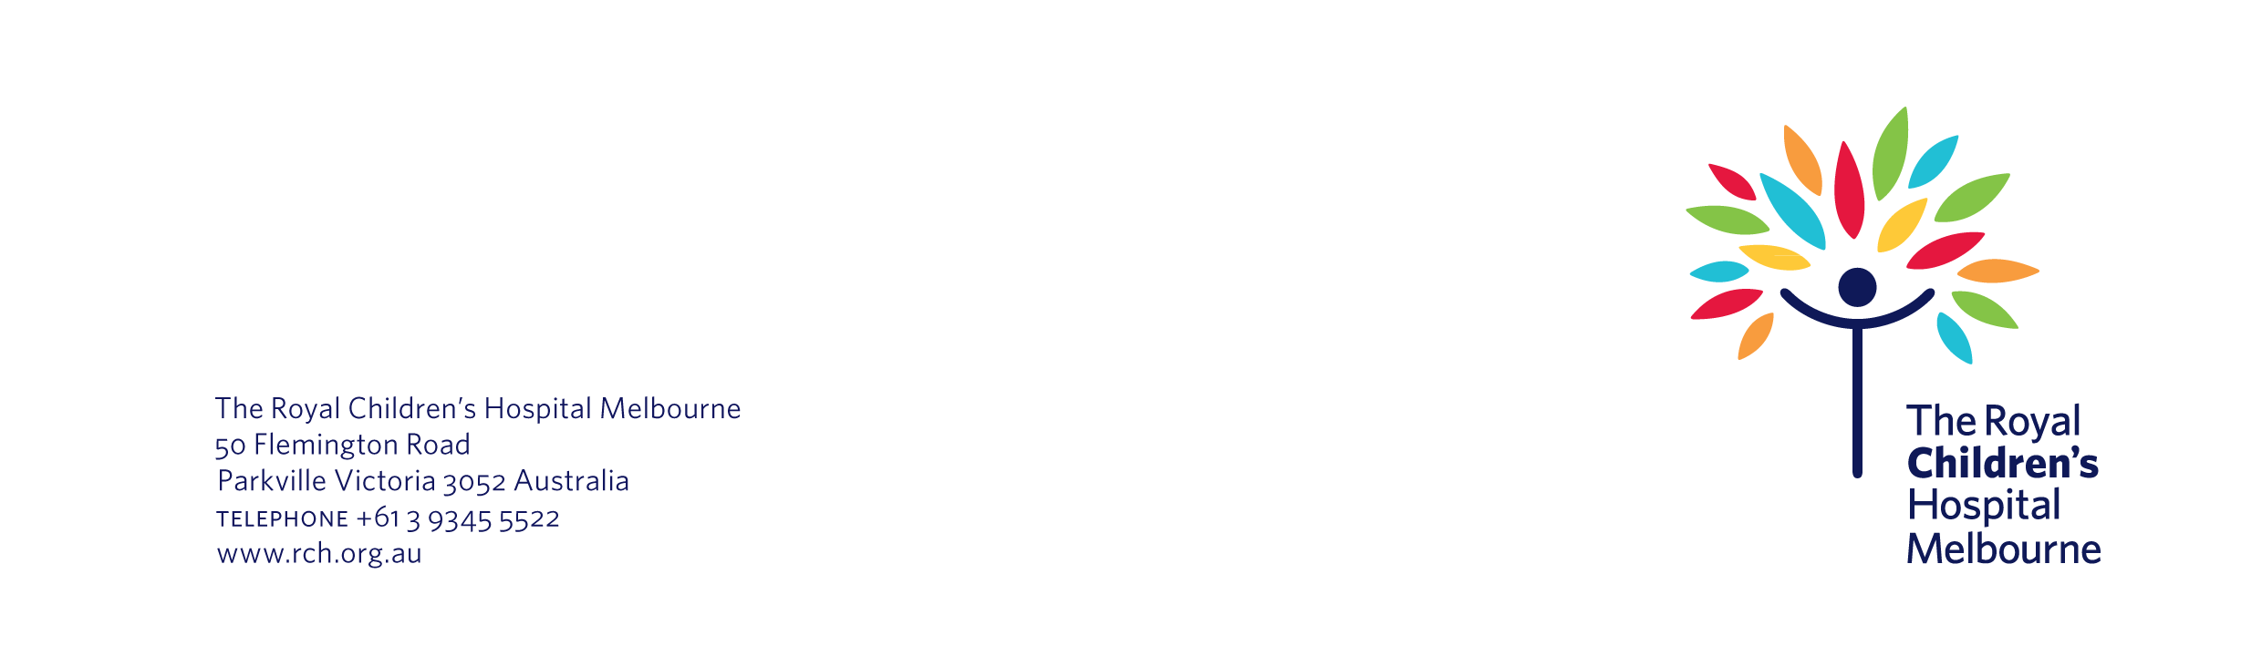
Name
Number/Street Name
Suburb
State/Postcode

Date

Re: Would you like to take part in a research project at The Royal Children’s Hospital?

Dear Mr/Ms Surname

We are writing to let you know about a new research project that is taking place at The Royal Children’s Hospital. The project is about <insert plain language description>. You and your child may be interested in taking part in this project.

Why are you being asked?

We are sending you this information because <you agreed to be contacted about new research project about <insert name>>. OR <Your child was recently treated in the <insert department name>. Your child has <insert condition> and may be suitable to take part>.

What is the research about?

As part of this project, we want to find out <insert brief description of the aims of the project>.

We have enclosed an information statement and consent form about the project. This form explains the research in more detail, including:

- what is involved if you and your child take part
- the risks and benefits of participation
- happens to the information we would collect about you and your child
- how we keep you and your child’s information confidential.

What happens next?

We would be grateful if you would consider taking part in the project. The information statement and consent form will help you make a decision about this.

Please contact us if you would like to take part in the project, or would like more information. You can call <insert name of researcher> on <insert phone number>. Alternatively, you can email them on <insert email address>.

If we do not hear from you by <insert date>, we will contact you to check you received this letter.

Kind regards

Name
Department
The Royal Children’s Hospital

